Machu Picchu, Peru: Wonder of the World

At an altitude of about 8000 feet, Machu Picchu, now one of the 7 wonders of the world, is a small city in the Andes, about 44 miles northwest of Cuzco, Peru, which was once the political heart of the Inca Empire.. and about 3000 feet above the Urubamba Valley. It covers 80,000 acres and means "Old Peak" in the indigenous Quechua.

History of the Lost City

Inca ruler Pachacuti Inca Yupanqui (or Sapa Inca Pachacuti) built Machu Picchu in the mid-15th century. It appears to have been a royal estate or sacred, ceremonial city with an astronomical observatory. The largest peak in Machu Picchu, called Huayna Picchu, is known as "hitching post of the sun."
The city was probably occupied for fewer than 150 years. Smallpox devastated Machu Picchu before the conqueror of the Inca, the Spaniard Francisco Pizarro, arrived. Yale archaeologist Hiram Bingham discovered the ruins of the city in 1911.
Most of the roughly 150 buildings in Machu Picchu were built of granite so their ruins look like part of the mountains. The Inca made regular blocks of granite fit so tightly together (without mortar) that there are areas where a knife cannot fit between the stones. Many buildings had trapezoidal doors and thatched roofs. They used irrigation to grow corn and potatoes.
Most recent archaeologists believe that Machu Picchu was constructed as an estate for the Inca emperor Pachacuti (1438–1472). Often referred to as the "Lost City of the Incas", it is the most familiar icon of Inca civilization. The Incas built the estate around 1450 but abandoned it a century later, at the time of the Spanish conquest. According to the new AMS radiocarbon dating, it was occupied from c. 1420–1532.^{[11]} Historical research published in 2022 claims that the site was probably called Huayna Picchu by the Inca, as it exists on the smaller peak of the same name.^{[12]} ^{[13]}
Machu Picchu was built in the classical Inca style, with polished dry-stone walls. Its three primary structures are the Intihuatana, the Temple of the Sun, and the Room of the Three Windows. Most of the outlying buildings have been reconstructed in order to give visitors a better idea of how they originally appeared.^{[14]} By 1976, 30% of Machu Picchu had been restored^{[14]} and restoration continues.^{[15]}

Facts about the Machu Picchu

This magnificent landmark stands at more than 7,000 feet (2.13 km) above sea level in the Andes mountains in Peru.

Machu Picchu is the most toured tourist destination in Peru. It is a representation of the Incan Empire and was built around 1450AD.
It was listed as a UNESCO World Heritage Site in 1983 and was named one of the New Seven Wonders of the World in 2007.

In the Quechua Indian language, “Machu Picchu” means “Old Peak” or “Old Mountain.”

This sacred place was an Incan stronghold built high in the Andes Mountains above the Urubamba River valley.

It is famous for its advanced dry-stone walls that link together huge blocks without mortar.

The buildings on the mountain were strategically arranged to astronomical alignment and has the best panoramic views of the hills and the valley below.
Its exact former use remains a mystery.

This fascinating architecture is a testament to the peak of the Inca Empire while in power and its achievements. To date, the exact use of the fortification is still unknown

The Incas Empire did not adopt the use of wheels or animals in transporting heavy rocks up the mountain, despite this they were able to build one of the most impressive kingdoms in history.

There are more than 150 buildings that make up the Machu Picchu. They vary in use from temples, sanctuaries, baths and houses.

Machu Picchu
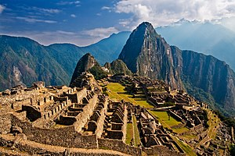
Machu Picchu in 2009
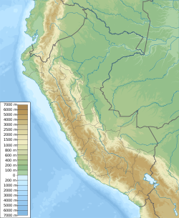
Shown within Peru
Location | - Peru  - └ Cusco Region
Coordinates | 13°09′48″S 72°32′44″WCoordinates: 13°09′48″S 72°32′44″W
Height | 2,430 meters (7,970 ft)
History
Founded | c. 1450
Abandoned | 1572^{[1]}
Cultures | Inca civilization

